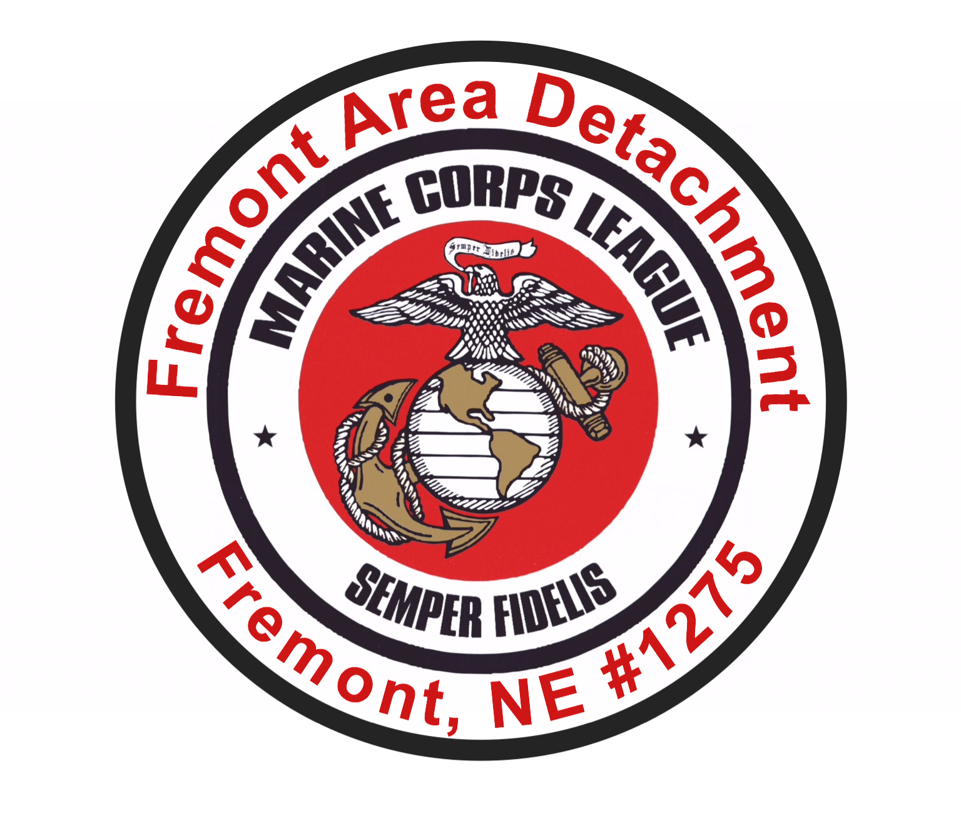
MARINE CORPS LEAGUE SCHOLARSHIPS

OCT. 17, 2023

TO: Marine Corps League Scholarship Applicants.
FROM: James Havelka, Scholarship Committee Chairman, Fremont Area Marine Corps League Detachment 1275.
RE: 2024 Marine Corps League Scholarships

Dear Applicant,

Detachment 1275 of the Fremont Area Marine Corps League, has again decided to award two, $1,000 scholarships to members of the Class of 2024 in its area high schools. The two scholarships are competitive and open to all Seniors at the eligible schools. The eligible high schools are: Fremont High, Archbishop Bergan High, North Bend Central High, Cedar Bluffs High, Logan View High, Arlington High, Wahoo High, and Bishop Neumann High. There is NO required commitment to enter the Armed Forces or to be the descendant of a veteran.

Seniors who plan to attend a four-year or two-year college or vocational school are eligible. Criteria for selection include academic achievement as documented by GPA, ACT/SAT scores, and evidence of advanced coursework; high school and community activity participation; community service activities; character and exemplary personal qualities as documented by a letter of recommendation, and completion of a brief personal essay.

Applications on the Detachment’s form (available from your Counselor) are due back to the high schools’ Guidance Counselors by the end of the school day on Monday, March 4, 2024.

The Detachment’s selection committee will review the applications and notify Guidance Counselors of the winners sometime after Monday, Mar. 21. The scholarships will be payable in January, 2025, upon demonstration of successful completion of the first semester of post-secondary school. Scholarship winners will receive a letter from me explaining these procedures.

An application form (in Word format) has been sent to each high school counselor along with this announcement. Further information on the scholarships can be obtained from James Havelka at the address below.

Sincerely,

JAMES P. HAVELKA,
Detachment Scholarship Chairman
P.O. Box 354
North Bend, NE 68649
jhavelka@gpcom.net
PH: 402) 620-1705

